EXP.NO: 1
DATE: Web Page Creation using HTML
29/01/2025

AIM:
To create a web page using HTML that embeds a map with interactive hotspots, frames, and links. The page should use inline, internal, and external CSS for styling. This exercise helps in understanding multimedia integration, interactive elements, and different CSS techniques for web design.
ALGORITHM:
Create the HTML structure:
- Set up the basic HTML document with &lt;<!DOCTYPE html>,<html>, <head>and
<body> tags.
- In the <head>, link the external CSS file (<link> tag), define the title, and include any metadata.
- In the <body> create the necessary elements:
1) Frames: Use the <iframeset> tag to create a frame layout (for older browsers,
use <iframe> instead).
2) Map: Use the <img> tag to display a map.
3) Hotspots: Create clickable regions using the <map> and <area> tags.
4) Links: Add hyperlinks (<a>) to navigate to different parts of the page or
external sites.
Create CSS Styles:
- External CSS: In a separate file, define styles such as colors, fonts, and layout for the
entire page.
- Inline CSS: Use the style attribute within specific tags to apply styles (e.g., in<div>
or <p> tags).
- Embedded CSS: Inside the <style>tag in the<head> define styles for specific
elements like the map, frames, and text.
- Map with Hotspots: Use the <map> tag to create an image map.
Define the<area> tag for each hotspot, specifying the coordinates (e.g.,
coords=”x,y,x2,y2”;) for clickable areas on the map.
Frames:
- Use the <iframe> tag for embedding external content like a map or another webpage,
with attributes such as src for the URL, width, and height.
Add Links:
- Inside the <body> use the <a> tag to create links for navigation (for example, to link
to specific parts of the page or external sites).
Test the Page:
- Test the webpage to check the functionality of frames, hotspots, and links. Ensure that
the map hotspots are clickable and the linked content displays correctly.
Ensure that the styles are applied properly using inline, embedded, and external CSS.
CODE:
<!DOCTYPE html>
<html lang="en">
<head>
<meta charset="UTF-8">
<title>Online Blood Donation Management System</title>
<link rel="stylesheet" href="style.css">
<style>
body {
font-family: Arial, sans-serif;
background-color: #ffe6e6;
margin: 0;
}
header {
background-color: darkred;
color: white;
text-align: center;
padding: 20px;
}
.section {
background-color: white;
width: 90%;
margin: 20px auto;
padding: 15px;
border-radius: 10px;
}
h2 {
color: darkred;
text-align: center;
}
.flex {
display: flex;
justify-content: space-around;
gap: 20px;
}
iframe, img {
width: 400px;
height: 250px;
}
a {
color: darkred;
font-weight: bold;
text-decoration: none;
display: block;
text-align: center;
margin: 6px;
}
</style>
</head>
<body>
<header>
<h1>Online Blood Donation Management System</h1>
<p style="font-size:18px;">Donate Blood, Save Life</p> <!-- Inline CSS -->
</header>

<div class="section">
<h2>Map & Hotspot</h2>

<div class="flex">
<iframe>
src="https://www.google.com/maps?q=Chennai+India&output=embed"
style="border:2px solid gray;">
</iframe>
<img src="https://static.vecteezy.com/system/resources/previews/008/186/625/non_2x/human-blood-donate-on-white-background-free-vector.jpg"
usemap="#bloodmap">

<map name="bloodmap">
<area shape="rect" coords="0,0,200,250"
href="https://www.redcross.org" target="_blank">
<area shape="rect" coords="200,0,400,250"
href="https://www.who.int" target="_blank">
</map>
</div>
</div>
<div class="section">
<h2>Frame & Links</h2>
<iframe src="https://www.wikipedia.org"></iframe>
<!-- Links -->
<a href="https://www.redcross.org" target="_blank">Red Cross</a>
<a href="https://www.who.int" target="_blank">World Health Organization</a>
<a href="https://www.naco.gov.in" target="_blank">NACO</a>
</div>
</body>
</html>
OUTPUT:
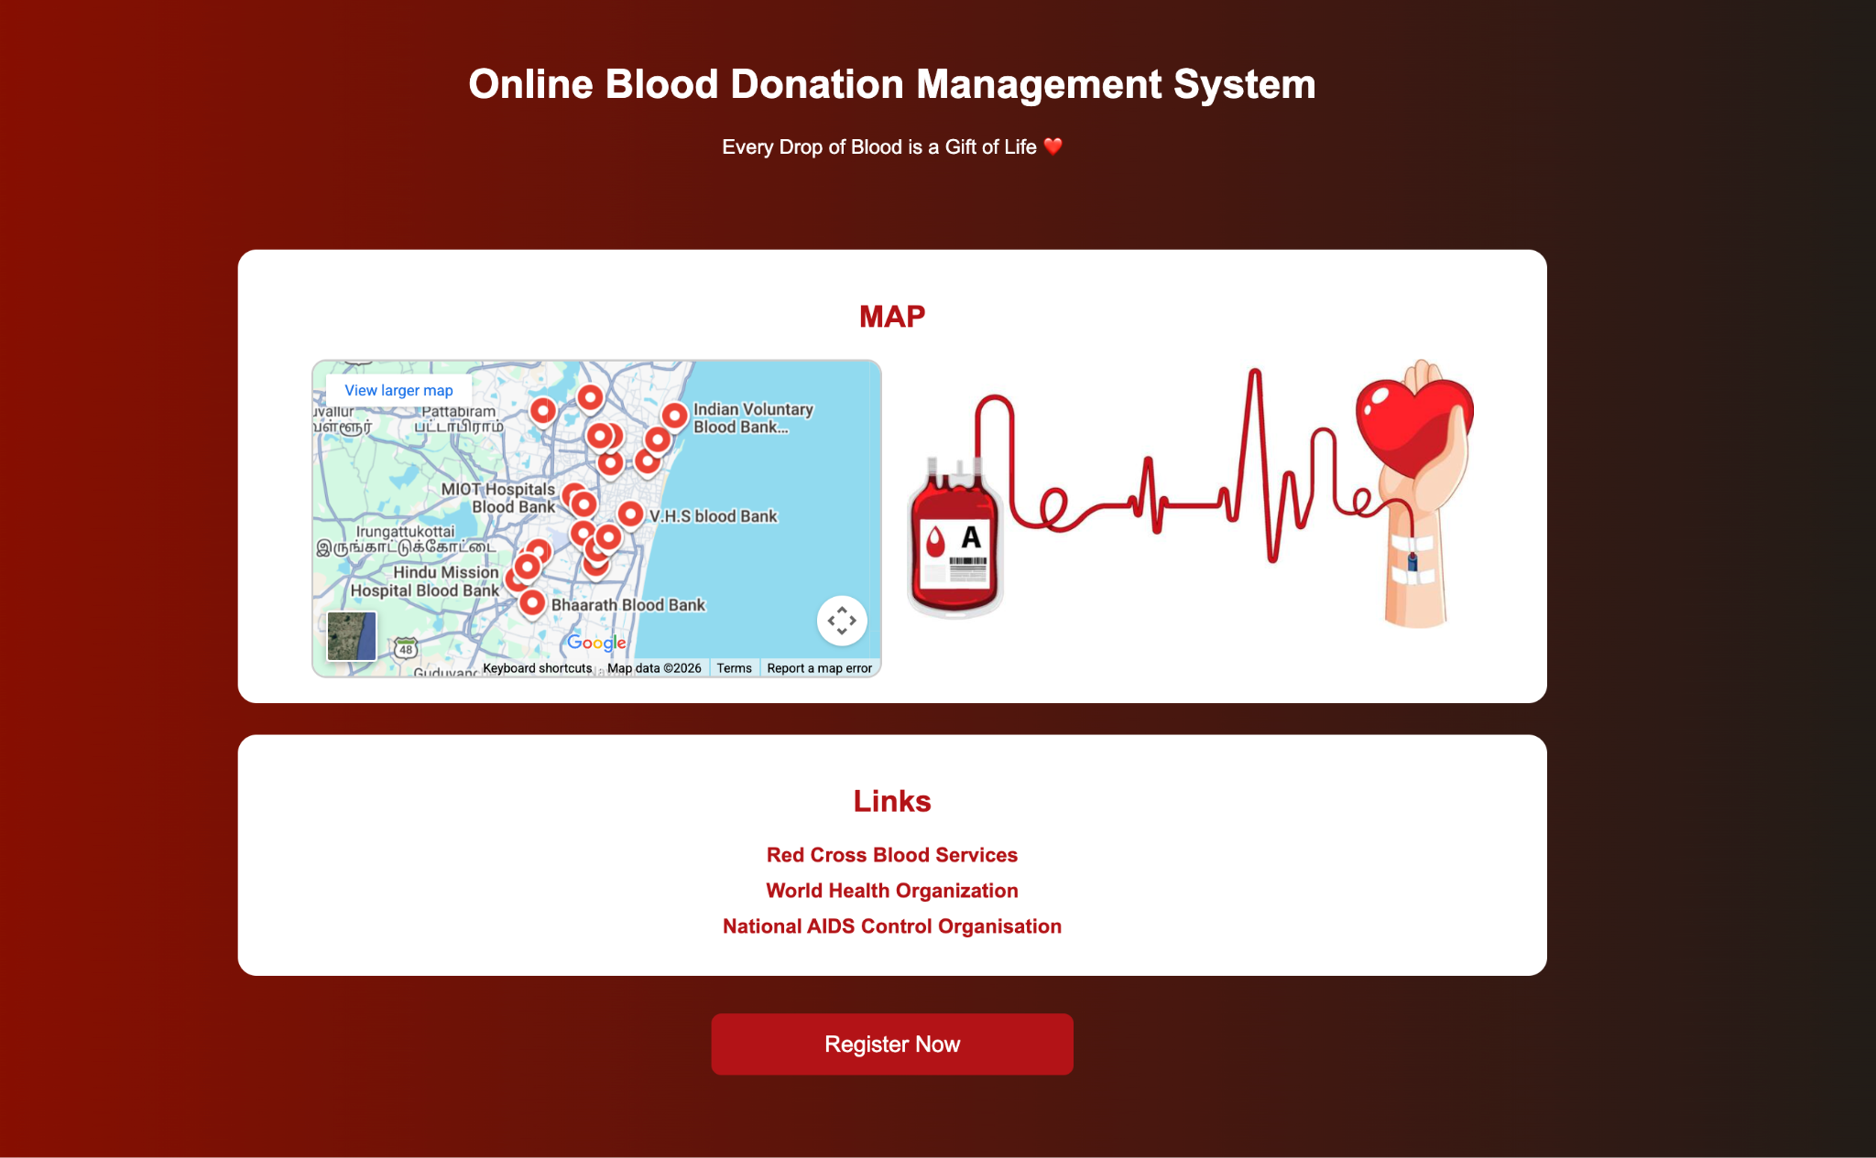
RESULT:
Html Page is created with embedded Chennai map along with hot spot, frames &amp;
links.

